COMMUNITY DEVELOPMENT BLOCK GRANT (CDBG)
49th Year (2023-2024)
VOLUNTEER HOUSING REHABILITATION APPLICATION

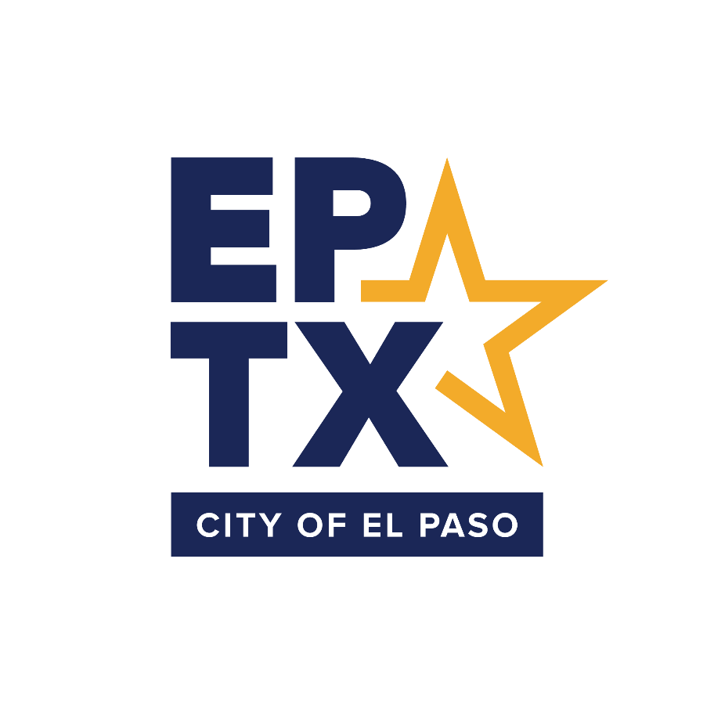
PREPARED BY THE DEPARTMENT OF
COMMUNITY AND HUMAN DEVELOPMENT

DEADLINE TO SUBMIT APPLICATION IS TUESDAY, FEBRUARY 21, 2023
Contact DCHDServices@elpasotexas.gov for technical assistance.

Applicant:
Project Name:
CDBG Funds Requested:

- Department Name or Legal Name of Entity:
- Type of Applicant: |  |  |  |  |  |  | Government Entity |  |  |  |  |  |  | Non-Profit Agency
- Address:
- Phone Number:
- Contact Person |  |  | ______________________________________________________
- Name: |  | _________________________________ |  |  |  |  |  |  |  | - Title: |  |  | _______________________________
- Phone Number: |  |  |  | ________________ |  |  |  | - Email Address: |  |  |  | ________________________________
- DUNS Number :

- Project Name:
- Main Address: |  | ___________________________________________________________________________
- Project Type (select one that applies):
______ Volunteer Housing Rehabilitation

- Funding Information
Amount of CDBG funding request…………………………………………………….. |  | $___________________
Amount of other committed cash resources*………………………………………. |  | $
*A minimum 10% committed cash contribution from a non-CDBG source must be provided. City Department applicants who would like to request a waive for this requirement must complete the attached Project Match Waiver Request Form.
Total project cost………………………………………………………………………….. |  | $

I hereby declare that the details furnished in, and attached to, this application are true and correct to the best of my knowledge and belief, and I undertake to inform you of any changes therein, immediately.
____________________________________________________ |  | __________________________________
Signature  Director / Executive Director / Chief Executive Director |  | Date
Print Name

- CDBG Eligibility. Check the HUD National Objective that applies to the proposed project from the following options:
______ Low-Mod Area Benefit (LMA) – provide service area:

______ Low-Mod Limited Clientele (LMC) – Note LMC activities must meet one of the following tests. Select the test that applies to your project:
______ Benefit a clientele that is generally presumed to be principally low-to-moderate income (LMI) This presumption covers abused children, battered spouses, elderly persons, severely disabled adults, homeless persons, illiterate adults, persons living with AIDS and migrant farm workers.
______ Require documentation on family size and income in order to show that at least 51% of the clientele are LMI.
______ Have income eligibility requirements limiting the activity to LMI persons only.
______ Be of such a nature and in such a location that it can be concluded that clients are primarily LMI. An example is a day care center that is designed to serve residents of a public housing complex.
______ Elimination of Slum and Blight. The focus of activities under this national objective is a change in the physical environment of a deteriorating area. Under the elimination of slums and blight national objective, determining the extent of and physical conditions that contribute to blight is central to qualifying an activity.

- Project Description
- Summary. Provide a brief paragraph summarizing the project for which funding is requested.

- Scope of Work. Provide a detailed scope of work for the project.

- Project Location
- Neighborhood Description. Describe the surrounding neighborhood and the logical boundaries affecting access.

- Project Justification.
  - Community Need. Describe (1) the community problem this project should address, (2) how this project is expected to resolve the given issues, (3) the public benefit that should come from this project.

- Client Determination.
  - Client Eligibility. Describe (1) how each homeowner will be deemed eligible for a home repair. (2) Describe what the process is after the repair is completed. For example, is there a punch list and walk through?

- Environmental Considerations. Applicants must provide a map showing the area(s) in which the rehabilitation projects will take place. These maps will be forwarded to the DCHD Compliance Division for review.
______ Attach map(s) of the Districts in which the rehabilitation projects will take place.

- Outcome Performance Measurement. HUD requires recipients to assess the outcomes for all its projects. The City of El Paso utilizes an Outcome Performance Measurement System to establish and track measurable outcomes and objectives for all of its HUD-funded programs. All approved applicants will be required to submit an Outcome Performance Measurement Worksheet.

______ Complete attached Outcome Performance Measurement Worksheet.

- Relocation Assistance and Payments. Federal regulations require that all tenants (residential, commercial or industrial) who are permanently or temporarily displaced as a result of CDBG-funded projects must be afforded financial benefits and advisory services.
Will any tenants be permanently or temporarily displaced as a result of this project?
 |  | Yes* |  | No
*If yes, contact the DCHD’s Housing Division at (915) 212-0139 for consultation on relocation benefits

- Previous CDBG Assistance.
  - Has the applicant been awarded previous years’ CDBG funding from the City of El Paso for this particular project? ______ Yes* ______ No
* If yes, indicate below the grant year, the awarded amount and the purpose of the funding. Use an additional sheet, if necessary.

Program Year | Awarded Amount | Purpose of Funding
 | $
 | $
 | $
 | $
 | $
 | $
 | $
 | $
 | $
 | $
Note: Funding for the ongoing program year must be assigned to one line. One line can be used to describe each previous CDBG funding for other years.

  - Has the applicant previously received a CDBG grant or loan from the City of El Paso for any other project(s) to include public service, public facilities, or economic development projects? ______ Yes* ______ No
* If yes, indicate below the grant year, the awarded amount and the purpose of the funding. Use an additional sheet, if necessary.

Program Year | Awarded Amount | Purpose of Funding
 | $
 | $
 | $
 | $
 | $
 | $
 | $
Note: Funding for the ongoing program year must be assigned to one line. One line may be used to describe each previous CDBG funding for other years.

- Other Funding Commitments. Indicate all other non-CDBG commitments from private foundations, private donors, lending institutions, another federal funding source, etc. that will be used towards this project. This should at minimum reflect the applicant’s 10% required cash contribution.

Loan, grant or cash? | Amount | Funding Source | Purpose
 | $
 | $
 | $
 | $
 | $
 | $
 | $
 | $
 | $
 | $
 | $
 | $

- Other Funding Opportunities. Has the applicant requested/applied for funding from other sources, which would cover the same scope of work proposed in this application?
______ Yes* ______ No
* If yes, indicate below the funding source, the amount requested, the amount approved/denied, and if this funding request is still pending.
Funding Source | Amount Requested | Amount Approved | Amount Denied | Pending? Y/N
 | $ | $ | $
 | $ | $ | $
 | $ | $ | $
 | $ | $ | $
 | $ | $ | $

- Schedule A. Summarize the budget costs for the Volunteer Housing Rehabilitation program.
COST COMPONENT | CDBG Funding Request | Other Cash Resources | Value of In-Kind Contributions* | TOTAL PROJECT COST
Travel
Postage + Shipping
Printing
Membership Dues
Communications
Rent
Telephone
Utilities
Insurance
Contractual Services
Project Budget
Office Supplies
Volunteer Support
Public Relations
Advertising
Other (specify)
TOTAL OPERATING BUDGET | $ | $ | $ | $
* Do not include In-Kind Contributions in line item for Total Project Cost.
VOLUNTEER HOUSING REHAB APPLICATION-SPECIFIC COMPLETENESS CHECKLIST
Applicant must complete the following Completeness Checklist to confirm that all required documents have been attached to the application. Documents must be attached to the application in order for the applicant’s submission to be considered completed.
For Applicant Use | THIS SECTION APPLIES TO ALL APPLICANTS | For Applicant Use
 | General Completeness Checklist from Policies and Procedures with related attachments
 | Applicant designee attended mandatory training workshop
 | Project location map that clearly defines project area
 | Outcome Performance Measurement Worksheet
 | Documentation that DCHD staff was consulted for relocation benefits (if applicable)

GENERAL COMPLETENESS CHECKLIST
(FROM POLICIES AND PROCEDURES)
The following documents must be attached to each application. This checklist does not apply to City departments.
Refer to your respective application for an additional completeness checklist that provides further requirements that are unique to the program.
For Applicant Use |  | For  DCHD Use
 | THIS SECTION APPLIES TO ALL APPLICANTS
 | Assurances A – Acceptance of Grant Conditions and Terms of CDBG, HOPWA and ESG
 | Assurances C – Assurance of Compliance with Ordinance No. 9779
 | Assurances D – Accessibility / Letter of Assurance
 | Attendance of the Mandatory Training Workshop by appropriate personnel
 | Zoning Conformance – must attach Zoning Verification Letter
THIS SECTION APPLIES TO NON-MUNICIPAL GOVERNMENT ENTITIES
AND NON-PROFIT AGENCIES ONLY
 | List of Current Board of Directors (Certified by Board President and Secretary)
 | Certified audit, completed within past 12 months, and covering a period ending on a date after January 31st from two years prior to the upcoming program year (e.g., an audit covering a period ending on a date after January 31, 2019 must be submitted for an application that is being submitted for the 2021 program year)
 | Written minute action and/or Board approval documentation signed by the Board President authorizing submittal and signature of the CDBG application by Board President (or other authorized representative)
 | THIS SECTION APPLIES TO NON-PROFIT AGENCIES ONLY
 | Assurances B – Assurances of Applicant Eligibility for Non-Profit Organizations
 | Certificate of Status from the Texas Secretary of State
 | Organizational By-Laws
 | IRS 501 (c)(3) certification letter

Volunteer Housing Rehabilitation Attachment 1
Outcome Performance Measurement Worksheet
(must be completed by all applicants)
The Outcome Performance Worksheet is composed of five project components:
- Objective – describes the goal of the project based on its intent. Applicant must select one objective from the following options:
- Create a suitable living environment. This objective relates to activities that are designed to benefit communities, families, or individuals by addressing issues in their living environment (such as poor quality infrastructure) to social issues such as crime prevention, literacy or elderly health services.
- Provides decent affordable housing. This objective focuses on housing programs where the purpose of the program is to meet individual, family, or community needs and not programs where housing is an element of a larger effort, since such programs would be more appropriately reported under suitable living environment.
- Create economic opportunities. This objective applies to the types of activities related to economic development, commercial revitalization, or job creation.

Note: Most public facilities projects meet objective #1.

- Outcomes - reflect the changes the applicant expects to occur in clients’ lives and/or the community as a result of the proposed activity. Applicant must select one outcome from the following options:
        - Improve availability and/or accessibility. This outcome applies to activities that make services, infrastructure, public facilities, housing, or shelters available or accessible to low-to-moderate income (LMI) persons, including persons with disabilities. Accessibility does not refer only to physical barriers; it also includes making the affordable basics of daily living available and accessible to LMI people in the neighborhoods in which they live.
        - Improve affordability. This outcome applies to activities that provide affordability in a variety of ways in the lives of LMI persons. It can include the creation or maintenance of affordable housing, basic infrastructure hook-ups, or services such as transportation or day care.
        - Improve sustainability. This outcome applies to projects where the activity is aimed at improving communities or neighborhoods, helping to make them livable or viable by providing benefit to LMI persons through multiple activities or services that sustain communities or neighborhoods.

Note: Most public facilities projects meet outcome #1.

- Output Indicator – number of persons, or households, which will be assisted or served by this project.

- Description – description of the project proposal.
- Outcome Statement – a compilation of items #1-4.
Output Indicator + Outcomes + Description + Objective = Outcome Statement
For example, 52 households (output) will have new access or availability (outcome) to public sewer (activity) for the purpose of creating a suitable living environment (objective)
Provide the following information to complete your Outcome Performance Worksheet:

- What is your project’s objective? Select one of the following:
_____ | Create a suitable living environment
_____ | Provide decent affordable housing
_____ | Create economic opportunities
- What is your project’s outcome? Select one of the following:
_____ | Improve availability and/or accessibility
_____ | Improve affordability
_____ | Improve sustainability
- Provide project output indicator:
- Provide a short description of activity being performed:

- Generate project outcome statement:
(Output Indicator + Outcomes + Description + Objective = Outcome Statement)

