ASSURANCES - A

ACCEPTANCE OF GRANT CONDITIONS AND TERMS
COMMUNITY DEVELOPMENT BLOCK GRANT (CDBG), HOUSING OPPORTUNITIES FOR PERSONS WITH AIDS (HOPWA), AND EMERGENCY SOLUTIONS GRANT (ESG)

As the duly authorized representative for

(Agency name)

I understand and agree to the grant conditions and terms described in the DCHD Policies and Procedures manual and application packet for the 49th Program Year (September 1, 2023 to August 31, 2024). Should the El Paso City Council award CDBG/HOPWA/ESG funding for
,

(Project Name)

I understand that the award may be revoked by City Council should

(Agency Name)

fail to adhere to the schedule agreed upon for the project. I agree and acknowledge that if the award of funding is revoked by City Council at any time, the agency will not be entitled to any costs or damages from the City. Additionally, if there have been monies expended for project expenses, these monies will be reimbursed to the City.

Name Signature

Title Date

ASSURANCES – B

ASSURANCE OF APPLICANT ELIGIBILITY FOR NON-PROFIT ORGANIZATIONS

As President (Chairman) of the Board of Directors of , I
certify that the agency, as applicant for CDBG/HOPWA/ESG funding administered by the Department of Community and Human Development from the City of El Paso, Texas, has non-profit tax-exempt status under Section 501(c)(3) of the Internal Revenue Service Code at the time of application.

I also certify that _____________________________ is the Authorized Signatory for the agency, and has formal authorization from its Board of Directors to submit proposals and sign contracts on behalf of the agency for DCHD funding to the City of El Paso, Texas.

I further certify that a copy of the Articles of Incorporation, organizational by-laws, IRS 501(c)(3) certification letter, and the most current agency Audit Report or Audited Financial Statement is being included with the DCHD funding proposal.

Signature:

Name:

Date:

ASSURANCES – C

ASSURANCE OF COMPLIANCE WITH ORDINANCE NO. 9779

As of (Position Title) (Agency)

I certify on behalf of the stated organization that as applicant for CDBG/HOPWA/ESG funding administered by the Department of Community and Human Development from the City of El Paso, the entity will comply with the City of El Paso's Ordinance No. 9779 (Non-Discrimination Against Disabled Persons) and all requirements imposed by said Ordinance. The organization further certifies that in accordance with the foregoing requirements, no qualified person, shall on the basis of disability, be excluded from participation in or be denied the benefits of any program or activity receiving financial assistance from or operated by the City of El Paso, or be subjected to discrimination with respect to employment by Grantees of the City of El Paso's financial assistance.

Signature:

Name:

Date:

ACCESSIBILITY/LETTER OF ASSURANCE- D

TO: ADA Accessibility Coordinator

DATE:

Sun Metro Mass Transit Department 5081 Fred Wilson
El Paso, Texas 79906 (915) 212-3005

As required by the City of El Paso, the applicant for funding, assistance from the City of El Paso, or contracting with the City of El Paso named below agrees to comply with the City of El Paso Ordinance #9779, Non-Discrimination Against Disabled Persons, and all requirements imposed by said ordinance. The applicant agrees that in accordance with the foregoing requirements, no qualified person shall, on the basis of disability, be excluded from participation in or be denied the benefits of any program or activity receiving financial assistance from or operated by the City of El Paso, or be subjected to discrimination with respect to employment by any recipient of City assistance.

Listed below are the exact addresses for all sites to be used for the proposed project. (If a section is not applicable, note reason - e.g. “Office in home” or “no rehearsal space.”). If you require further space, you may attach an additional sheet.

Administration: Program:

Program: Program:

Attached is a current Self-Evaluation form for each of the above sites. (If a completed Self-Evaluation form is on file at the proposed site, the applicant may provide a copy provided all information is current. If the site has been modified, or if a Self-Evaluation has not been performed on the site, the applicant must complete and submit a current form.
If the ADA Accessibility Coordinator has found a proposed site to be in Conditional or Non-Compliance status, the applicant must also submit a copy of the Transition Plan which is a written agreement between the location’s owners or occupants and the City detailing required changes to the site and the time frame to complete these changes. (There is no form for the Transition Plan.)
The applicant understands that any change in the approved site requires notification of the ADA Accessibility Coordinator in Capital Improvement Department at least 60 days prior to use of the new site. Questions regarding the above information may be addressed to the contact person listed below. The applicant will expect notification by letter of the accessibility status of each site.

Name of Organization Name of Contact Person

Address Phone of Contact Person

Phone Signature

GUIDELINES/SELF-EVALUATION FOR COMMUNITY DEVELOPMENT AND CITY OF EL PASO SUBRECIPIENTS

Agency Name: Telephone:

Address: Date:

Age of Facility:

Scope of Work
New Construction Renovation/Alteration Addition to Existing Building N/A Explain Person Filling Out Report:

Reference*
ADAAG & New construction must meet 2015 ADA Accessibility Guidelines and 2015 Texas TAS 201 Accessibility Standard Requirements.

ADAAG & Renovations/Alterations of an area of must meet the 2015 ADA Accessibility TAS 202 Guidelines and 2015 Texas Accessibility Requirements which includes upgrading
parking, the accessible route to and through the renovated area, the restrooms/bathrooms, drinking fountains, and public phones.

UFAS 4.6. 1.) Parking Spaces
ADAAG & a. How many total parking spaces?
TAS 208, b. How many are accessible for the disabled?
502 c. How wide is accessible parking space? (8’ min.)
- How wide is accessible access aisle? (5’ or 8’ for a van space)
- Is the accessible parking space on the shortest accessible route of travel from adjacent parking to the accessible entrance? Yes No
If no, please explain:

- Is at least one space a van accessible space (8’ space and an 8’ access aisle or 11’ space with a 5 access aisle)? For every six accessible parking spaces one must be a van accessible space. Yes No
If not, please explain:

Reference*
- If a car is parked in the accessible space, is the sign visible? (sign on pole or wall mounted at least 60” above the parking surface) Yes No
- Is/are the space/s and access aisle/s level with no slope over 1:50 (2%) in any direction? (Flat) Yes No

UFAS Table 4.1.1 & Figure 9 ADAAG/TAS

Table 208.2 & Figure
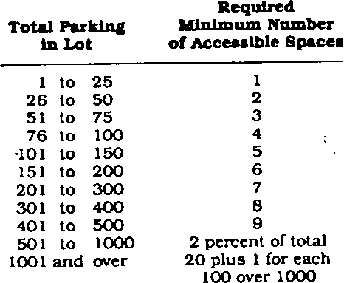502.2 and 502.3

Table 4.1.1
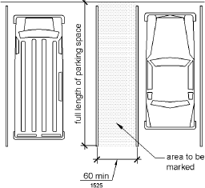
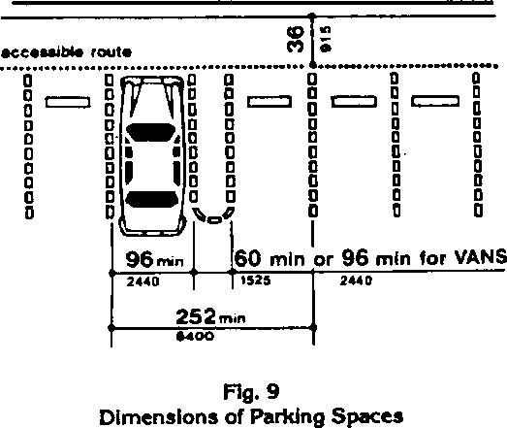
Figure 9, 4.6, 502.2
Figure 502.3

UFAS 4.5 2.) Is there a continuous, smooth, level, hard-surfaced pathway at least 36" ADAAG/TAS wide, with no level changes greater than 1/2" from accessible parking to the 206 & Chap. 4 and entrance? Yes No

UFAS 4.8 3.) If there are changes in level, are ramps provided? Yes No
ADAAG/TAS a. What is total change in height (inches)? (more than ¼”)
405 b. What is the ramp length (feet)? (1’ in length for each inch rise)
c. Are handrails provided? (required if more than 6” rise) Yes No

UFAS 4.13.6 4.) Maneuvering Clearance at Door (Doors are part of the Accessible route 305, 404 and must be brought into compliance if an area of primary function is renovated.)
- What are the dimensions of the level maneuvering area at front entrance door? (4’ X5’ min)
- Does the door swing in or out?
- Indicate approach direction and dimensions of level maneuvering space

by drawing entry dimensions as shown in the example below.

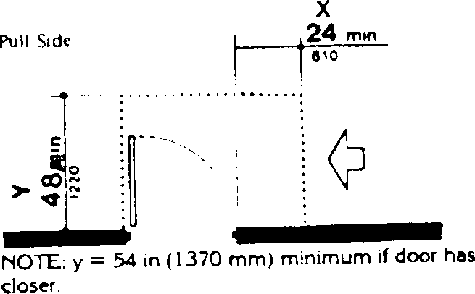

Reference*

Figure 25
Entry sketch

UFAS 4.13.5 5.) What is the clear width of front entrance when door is open? (32” min.) ADAAG/TAS 404

UFAS 4.5 6.) Is floor non-skid surface, or low-pile carpet of 1/2" or less and firmly ADAAG/TAS 403 attached? Yes No
If no, please explain:

UFAS 4.13.5 7.) All interior doors must provide clear width of 32" when open. Complete ADAAG/ TAS the following chart for interior doors. (List doors in building)
405 a. Do all doors comply? Yes No

Clear Width Clear Width
Room (inches) Room (inches)

Add additional sheets if needed.

UFAS 4.13.9 ADAAG/ TAS 405 |  | b. Do all accessible doors have handles, pulls, latches, locks, and operating devices that have a shape that is easy to grasp with one hand and does not require tight grasping, pinching or twisting of the wrist to operate? (No Knobs) Yes No  If no, please explain:
Reference* UFAS 4.10 | 8.) | The building is story(ies) high.
ADAAG/TAS |  | Does the building have an elevator? Yes No

407 If yes, complete the following:
- What is elevator door width? (36” min)
- What are inside dimensions? (51” X 68”)
- How high above floor are call buttons? (48”)
- How high are highest car control buttons? (48”)
- Do control buttons have raised characters or Braille? If no, please explain:

UFAS 4.4.1  ADAAG/TAS | 9.) | Are all wall-mounted elements (phones, fire extinguishers, signs, etc.)  mounted with their leading edges at or below 27 inches?
(204, 307 |  | Yes No If no, please explain:

- Does the element protrude over 4 inches from the wall? Yes No
- If the element protrudes over four inches from the wall into the accessible route, is the element protected by means of curb, ground mounted object, etc.? Yes No If no, please explain:
Figure 8
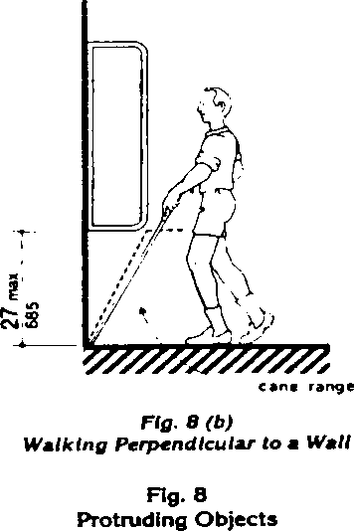

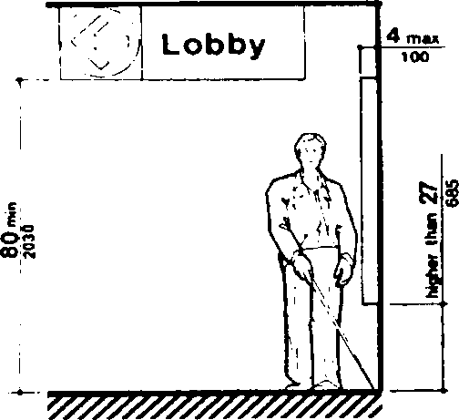
10.) Restroom Facilities (If an area of primary function is renovated then the restrooms must be brought into compliance.)
Are toilet facilities provided in rooms having multiple stalls or in individual rooms?
Multiple Stalls Individual Rooms

UFAS 4.16 - If multi-stall:
4.23 a. What is clear width at main restroom entrance when door is open? (32” min.) ADAAG/TAS
213, Chap. 6 b. What is the clear width of the aisle to the accessible stall? (36” min.)
- What are the dimensions of the accessible stall? (56” X 60” min.)
Depth Width
- What is the distance from the wall to the center of the toilet. (16” to 18”)

- Does stall door swing in or out?
- Does accessible stall/toilet have grab bars? Yes No
  - Length of grab bars (36” back 42” side)
  - Location (side/back)
  - Mounting height above floor (33” to 36”)
- What is toilet seat height from floor? (17” to 19”)
- Is the flush valve on the open side of the toilet?
i. What is lavatory rim height from floor? (34” max)

j Do clearances comply with Fig. 31 & Fig. 32 (below)? Yes No
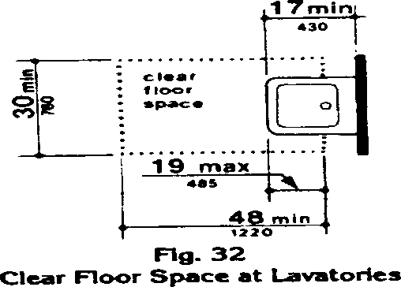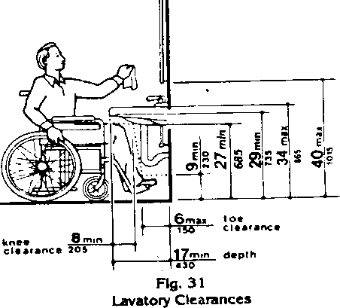

- Is there clear floor space of 30" x 48" minimum? (Fig. 31) Yes No
- Are hot water and drain pipes below sink insulated or otherwise covered?
Yes No
- What are heights of top and bottom edges of accessible mirror from floor?
Bottom edge (40” max.) Top edge (74” min.)
- Are all dispensers easy to reach and no more than 48” from floor to bottom of dispenser? Yes No
If individual toilet rooms are provided, indicate configuration below:
- Room dimensions (Must have 5’ diameter turning area)
- Does the door swing into the clear floor space of any fixture? Yes No
- Fixture heights and location
  - What is toilet seat height from floor? (17” to 19”)
  - What is the distance from the wall to the center of the toilet. (16” to 18”)
  - What is lavatory rim height from floor? (34” max.)
d Does accessible toilet have grab bars? Yes No
    - Length of grab bars (36” back 42” side)
    - Location (side/back)
    - Mounting height above floor (33” to 36”
e Is there a clear space of 5 feet from the wall to the nearest fixture adjacent to the toilet (sink or urinal) and is flush valve on wide side of toilet? Yes No
- Do clearances comply with Fig. 31 & Fig. 32 (above)? Yes No
- Is there clear floor space of 48" x 30" minimum? (Fig. 31) Yes No
- Are hot water and drain pipes below sink insulated or otherwise covered?

Yes No

Reference*
- What are heights of top and bottom edges of accessible mirror from floor?
- Bottom edge (40 in. max) Top edge (74 in. min.)
- Are all dispensers easy to reach and no more than 48” from floor to bottom dispenser? Yes No

UFAS 4.15 11.) Is at least one water fountain accessible; no more than 36" in height measured ADAAG/TAS from the floor or ground surface to the spout with a 30" x 48” clear floor space in 211, 602 front of the water fountain? (If an area of primary function is being renovated then the water fountains must be made compliant.) Yes No
If no, please explain:

UFAS 4.31.3 12.) Is at least one phone accessible to the mobility impaired (no more than 48" ADAAG/TAS from the floor)? Yes No
217, 704 If no, please explain:

UFAS 4.31.9 13.) Do you have a Telecommunications Device for the Deaf (TDD)? ADAAG/TAS Yes No
217, 704 If no, please explain how service is provided to individuals with hearing impairments?

UFAS 4.28.2, 14.) Are emergency warning signals both audible and visual?
4.28.3 Yes No
ADAAG /TAS If no, please explain: 205, 702
15.) Is program information that is available in print, available on audio tape or in an alternative method? Yes No
If no, please explain:

16.) Are all public meetings accessible (with sign language interpreters) and in accessible locations? Yes No
If no, please explain:

*Reference number is from Uniform Federal Accessibility Standards, Americans with Disabilities Act Accessibility Guidelines, and Texas Accessibility Standards.
In the case that non-compliant elements are found and structural changes are needed, develop a transitional plan setting forth the steps necessary to complete such changes or alterations. The transitional plan shall contain, at a minimum, identification of physical barriers that limit accessibility; description of methods to make facilities accessible; time schedule for taking each necessary step; costs of changes; and name of person responsible for implementation of plan. Please attach this information to the self-evaluation.

Please be advised that you may have further obligations under the

Americans with Disabilities Act.

For questions or further information regarding these forms, please contact: Accessibility & ADA Coordinator
Sun Metro Mass Transit Department
5081 Fred Wilson El Paso, Texas 79906
212-3005

Please return Guidelines/Self-Evaluations and Transitional Plan along with the proposal application

PARTICIPATION IN HUD PROGRAMS BY FAITH-BASED ORGANIZATIONS; PROVIDING FOR EQUAL TREATMENT OF ALL HUD PROGRAM PARTICIPANTS;
FINAL RULE EFFECTIVE OCTOBER 30, 2003
- Organizations that are religious or faith-based are eligible, on the same basis as any other organization, to participate in the Community Development Block Grant (CDBG), Housing Opportunities for Persons with AIDS (HOPWA), or the Emergency Solutions Grant (ESG) program. Neither the Federal government nor a State or local government receiving funds under CDBG/HOPWA/ESG programs shall discriminate against an organization on the basis of the organization’s religious character or affiliation.
- Organizations that are directly funded under the CDBG/HOPWA/ESG program may not engage in inherently religious activities, such as worship, religious instruction, or proselytizing, as part of the programs or services funded under this part. If an organization conducts such activities, the activities must be offered separately, in time or location, from the programs or services funded under this part, and participation must be voluntary for the beneficiaries of the HUD-funded programs or services.
- A religious organization that participates in the CDBG/HOPWA/ESG program will retain its independence from Federal, State, and local governments, and may continue to carry out its mission, including the definition, practice, and expression of its religious beliefs, provided that it does not use direct CDBG/HOPWA/ESG funds to support any inherently religious activities, such as worship, religious instruction, or proselytizing. Among other things, faith-based organizations may use space in their facilities to provide HUD-funded services without removing religious art, icons, scriptures, or other religious symbols. In addition, a HUD-funded religious organization retains its authority over its internal governance, and may retain religious terms in its organization’s name, select its board members on a religious basis, and include religious references in its organization’s mission statements and other governing documents.
- An organization that participates in the CDBG/HOPWA/ESG program shall not, in providing program assistance, discriminate against a program beneficiary or prospective program beneficiary on the basis of religion or religious belief.
- HUD grants may not be used for the acquisition, construction, or rehabilitation of structures to the extent that those structures are used for inherently religious activities. HUD grants may be used for the construction or rehabilitation of structures only to the extent that those structures are used for conducting eligible activities under this part. Where a structure is used for both eligible and inherently religious activities, HUD grants may not exceed the cost of those portions of the construction or rehabilitation that are attributable to eligible activities in accordance with the cost accounting requirements applicable to HUD grants in this part. Sanctuaries, chapels, or other rooms that a HUD-funded religious congregation uses as its principal place of worship, however, are ineligible for HUD-funded improvements. Disposition of real property after the term of the grant, or any change in use of the property during the term of the grant, is subject to government-wide regulations governing real property disposition.

